3.When run camera code, some error will display, as shown below.
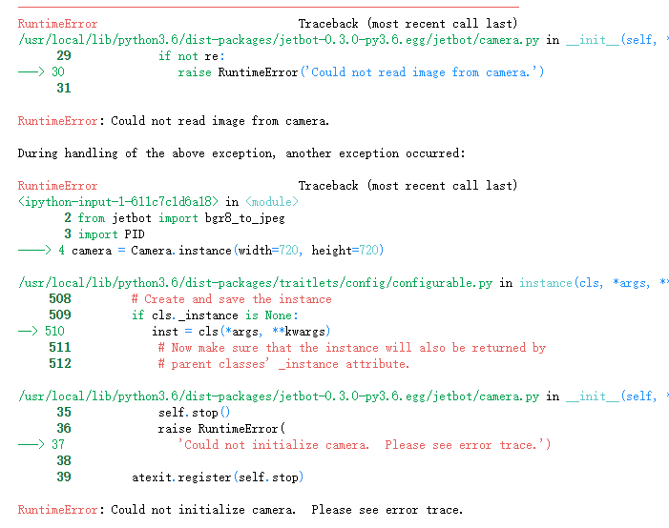
1) Please check if the camera is plugged in correctly.
2) Go to the command terminal and enter ls /dev to see if the video 0 device can be checked.
3) Click [kernel] on the jupyterLab interface, click [Shut down all kernels], and wait for 30S.
4) Click [Restart kernel and clear all outputs]... After waiting for 30s to clear, re-run the code.
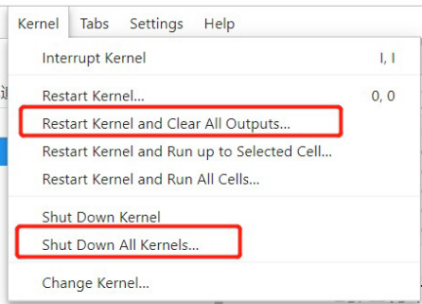
is display all the time

